Tableau Basics

Q1. Explain what Tableau is and why it is preferred over traditional spreadsheet tools for data analysis. Also mention any two industries where Tableau is commonly used and explain one use case.
Answer
- Tableau is a powerful data visualization and business intelligence tool that helps users analyze and present data interactively.
- Why preferred over spreadsheets:
  - Handles large datasets efficiently.
  - Provides interactive dashboards and real-time updates.
  - Drag-and-drop interface makes analysis faster and more intuitive.
- Industries using Tableau:
  - Retail: For analyzing sales trends and customer behavior.
  - Healthcare: For patient data monitoring and hospital performance.
- Use case (Retail): A retail chain uses Tableau to track product category sales across regions, identifying which categories drive profits and which need promotional support.

Q2. After connecting to the Sample – Superstore dataset:
a) List the main types of fields available (examples: time-based, geographical, numerical).
b) Identify any four Dimensions and any four Measures from the dataset.

Answer
- Types of fields:
- Time-based: Order Date, Ship Date.
- Geographical: Country, State, City, Postal Code.
- Numerical: Sales, Profit, Quantity, Discount.
b) Dimensions (blue fields):
- Category, Sub-Category, Region, Customer Name. Measures (green fields):
- Sales, Profit, Quantity, Discount.

Q3. Create a Bar Chart showing Total Sales by Category.
Explain: Which field goes to Rows Which field goes to Columns Which aggregation is applied to Sales.
Hint: Drag Category and Sales into the view and observe Tableau’s default behavior.

Answer

- Rows: Category (Dimension).
- Columns: SUM(Sales) (Measure).
- Aggregation: Tableau automatically applies SUM to Sales.
- Insight: Quickly shows which product categories generate the most revenue.
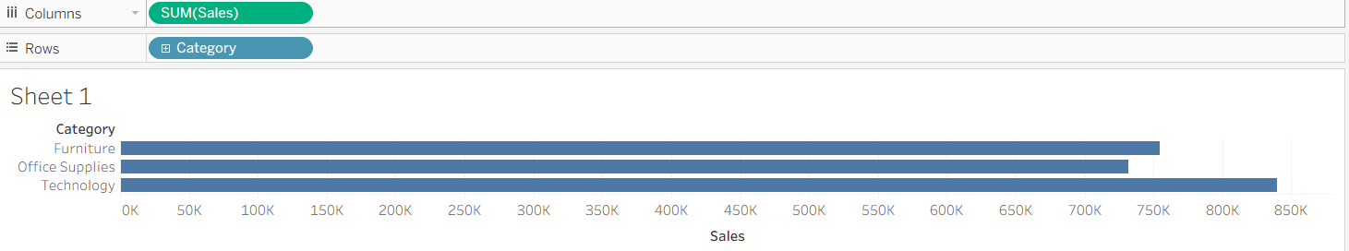

Q4. What insight can be gained by comparing Sales and Profit together? Then explain how you would create a chart to analyze Profit by Sub-Category.
Answer
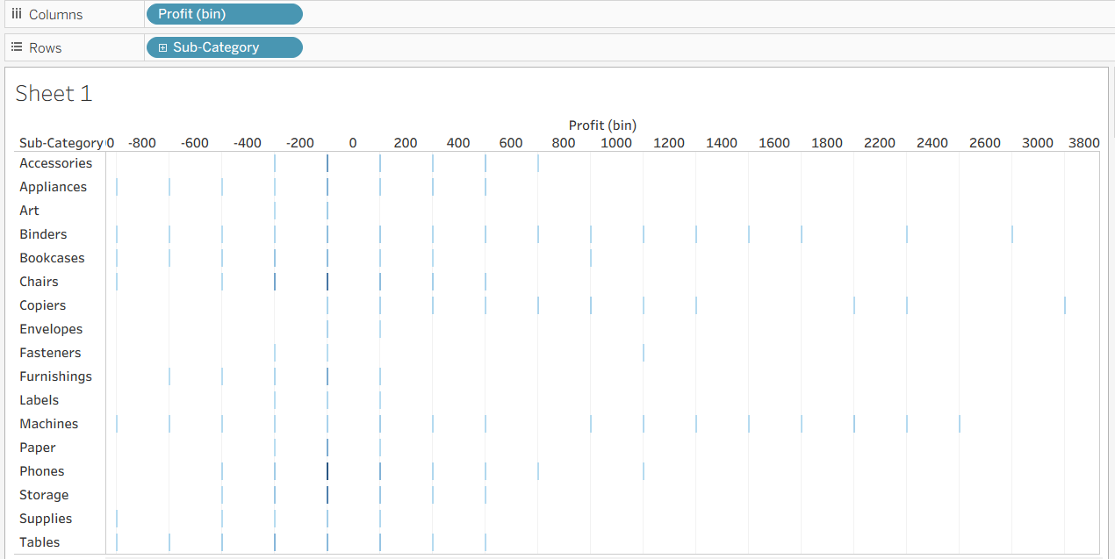

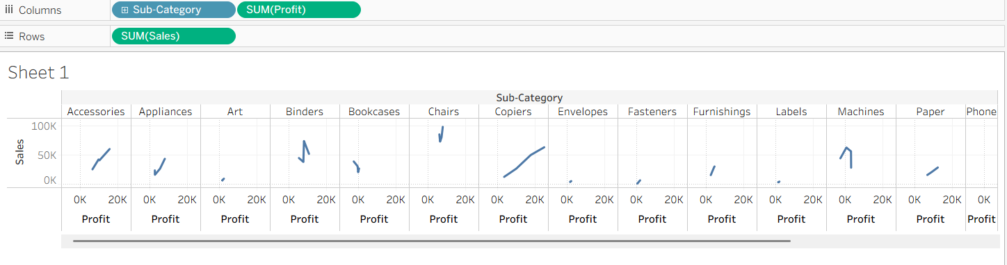
Sales alone doesn’t show profitability. A category may have high sales but low or negative profit (due to discounts or costs).

Q5. Create a Line Chart to show Sales Trend over Order Date. Which date level would you choose (Year / Quarter / Month)? Why are line charts suitable for time-based analysis?
Hint: Drag Order Date and change its date hierarchy from Year to Month if needed.
Answer:

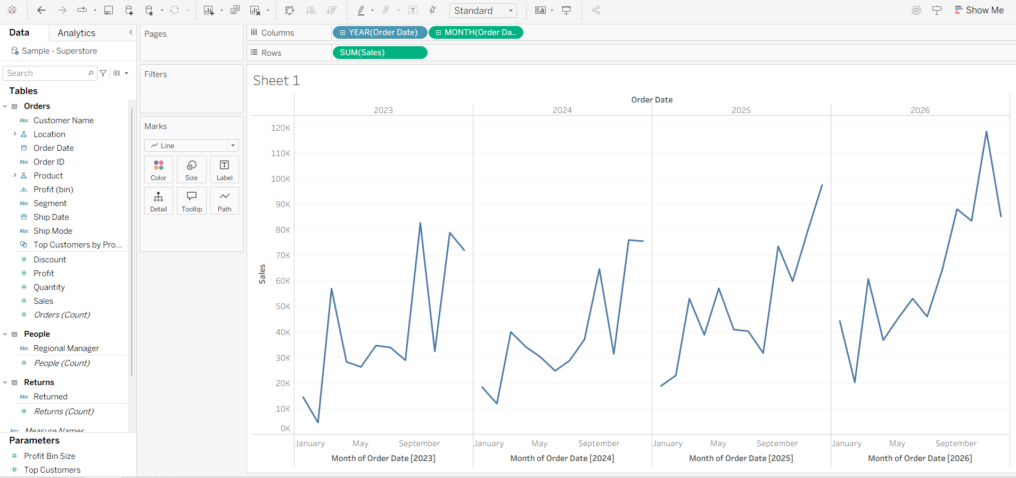

Q6. Apply a Basic Filter to display data only for: Region = “West” Category = “Technology” Explain the steps and mention which shelf is used.
Answer
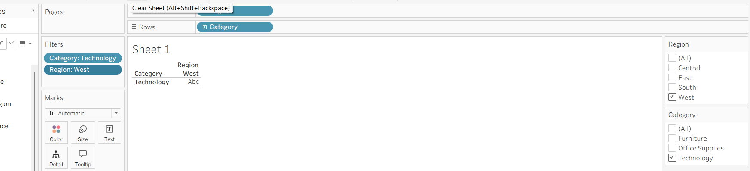

First I drag the region in the column & rows in the category and then I used filter region and category.

Q7. Explain the business importance of geographical analysis. Then describe how you would create a Map showing Sales by State using Sample – Superstore.
Hint: Use State and Sales. Tableau automatically detects geographic fields.
Answer

Business importance of geographical analysis : Helps to identify regional performance, market opportunity and areas needing improvement.

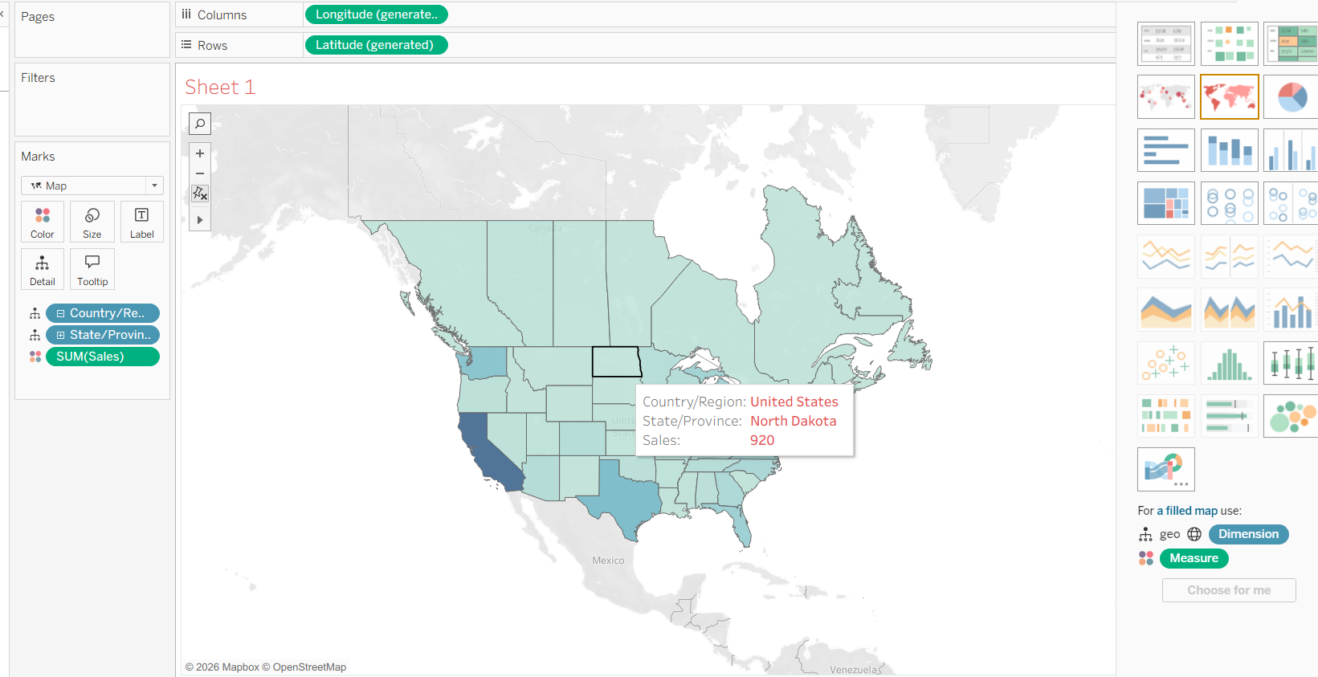

Q8. What is the difference between a Worksheet and a Dashboard in Tableau? Why is a dashboard more useful for decision-makers?

Answer
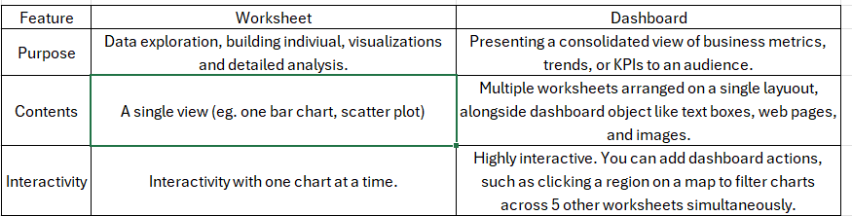

Q9. What is Tableau Prep, and why is it important in real-world data projects? What is Tableau Prep, and why is it important in real-world data projects?
Then explain how you would:
- Remove null values
- Remove duplicate records
- Change incorrect data types (Answer in steps, no tool access required.)

Answer
Tableau prep is a tool designed to help users visually prepare clean, and shape their data before analysis. It enables users to combine, shape, and clean messy data for easier use in Tableau Desktop.
Importance: Real-world data is messy; Prep ensures clean, reliable datasets.
Steps:
Remove null values: Use filters to exclude nulls.
Remove duplicates: Apply "Remove Duplicates" option in Prep.
Change incorrect data types: Select field → change data type (e.g., string to date).

Q10. A retail manager wants answers to the following:
- Which category generates the highest profit?
- Which region performs poorly?
- How does sales change over time?
- Mention which charts you would use
- Identify one key insight that management could derive
- Explain how this helps in business decision-making

Answer
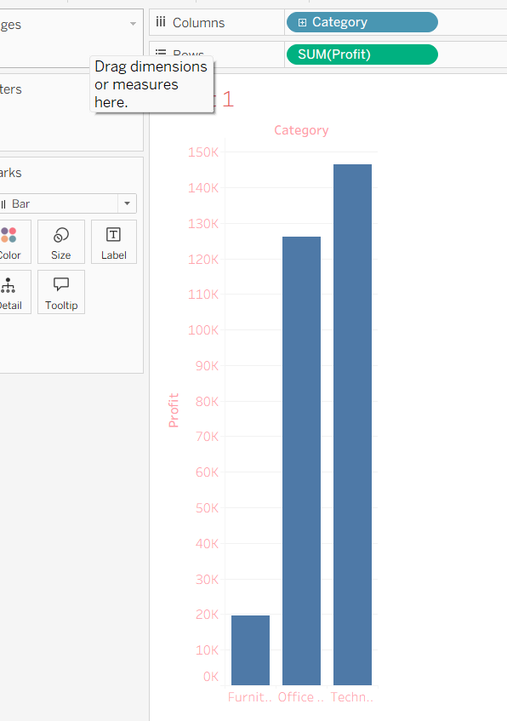
Technology generate the highest profit.

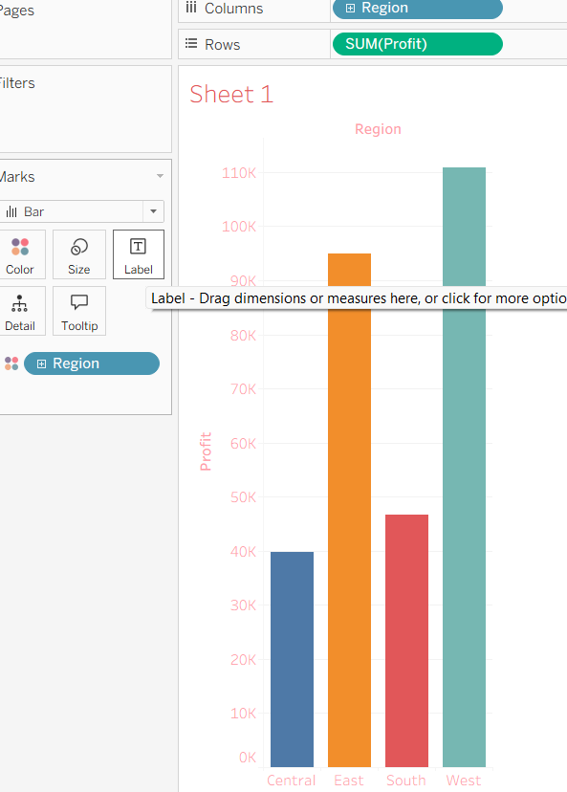
Technology category generates the highest profit, but the South region performs poorly.

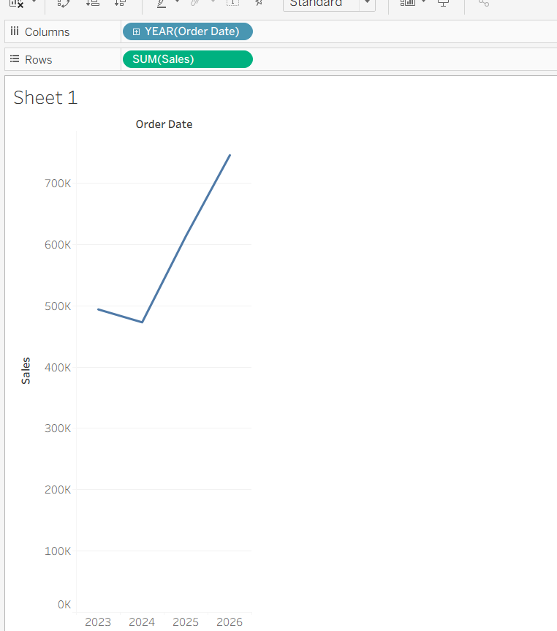
Business decision-making:
- Helps managers allocate resources, plan promotions, and improve regional strategies.
- Example: Increase marketing in South region, expand profitable Technology category.

